CAPSTONE PROJECT WEEKLY ACCOMPLISHMENT REPORT

Team Name: COREX Section: BSIT-3A Date: February 23 - March 1
Project Title: AUTOMATED EVENT SCORING MANAGEMENT AND TABULATION SYSTEM FOR SCHOOL ACTIVITIES

Accomplishment for the Week

Task / Activity | Description of Work Done | Output / Evidence
Drafting Chapter 1 Manuscript | Start Making the Chapter 1 | 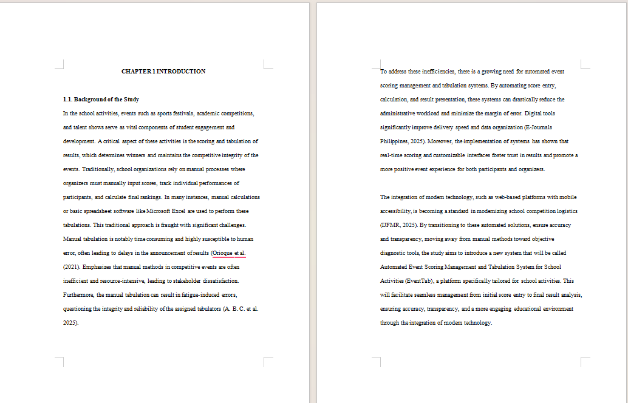
Designing a UI for web | Created the User Interface (UI) with an eye toward making the application visually appealing and easy to use. | 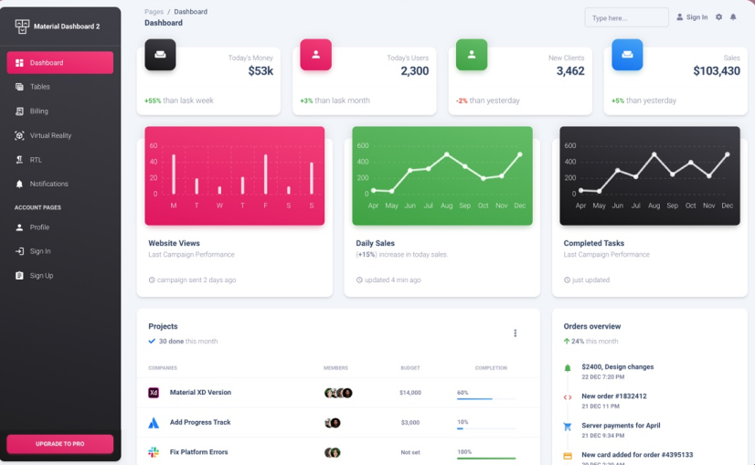
File and Folder Structure | Arranged the folder structure so that it was easy to locate the file. | 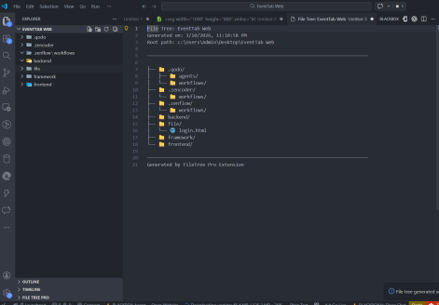

Individual Contribution

Team Member | Contribution
Gellyn S. Rabino | Documenter
Arlyn Kaye Allona D. Baluyos | Quality Assurance / Testing Specialist
Johny M. Roldan | Data / Analysis Specialist
Ian Kirby B. Duman-ag | Project Manager / Team Leader

Issues Encountered and Actions Taken

Issue/Concern | Action Taken / Resolution
Drafting Knowledge | Reviewed prior thesis samples and adhered to academic rules to make sure the paperwork satisfied the necessary requirements.
Difficulty in UI Design | Deciding which user interface design is best for the user.

Plan for the Next Week

Planned Task | Expected Output
Chapter 2 Drafting | Chapter 2 draft will be done
Technical Prototyping & Setup | Start preparing the database tables for implementation and configuring the development environment.
Create a Database Design | A draft of the database design will be completed.

Adviser’s Remarks

Reviewed by:

Mr. Hanes A. Ongos
Capstone Project Adviser
Date Signed:

Note:

- This report shall be submitted weekly to the Capstone Adviser.
- All members must actively contribute and be reflected in the report.
- Supporting evidence (screenshots, documents, commitments, etc.) may be attached.
- Submission of this report forms part of the progress monitoring and individual assessment of the Capstone Project.

